|  |  |  |  |  |  |
| --- | --- | --- | --- | --- | --- |
| **Module No:** | 1 | **IU No:** | 1 | **Exercise No.** | 1 |
| **Learner’s Name** | **Abarca, Francis Roel L.** | | BDSE-0922-113 | | |

|  |  |
| --- | --- |
| **Lab Assessment Statement** | **Assignment 1 - Build an API**  **Project Scenario,**  The scope of this assignment is to develop an API for ‘XYZ Cars Pte Ltd’ as a website developer to develop a Used Car Sales portal.  In this assignment, Users will be able to register in the portal using the  Registration Page. Users of the portal can search for Cars using Make, Model, Registration & Price Range. Users will be able to view the Car information after searching them. The portal allow users to login, post Car for sale.    These are the steps provided to build an API.     1. Create SpringBoot application [Spring Initializr.](https://start.spring.io/) Import the project in your IDE. 2. Create entities for your backend as per the scenario. 3. Create Repositories using JPA repositories. 4. Create service layer to access the data in your API 5. Create controller for your application using REST API   6. Test your API using POSTMAN tool.    **Provide the source code of developed application.**  **Provide screen capture of final result pages for API testing.** |
| **Technical**  **Environment** | -JAVA, JPA, REST API |
| **Guidelines** | - |
| **Duration** | 120 mins |

**Task View Solutions:**

**­­­­­­**Java Version used:  
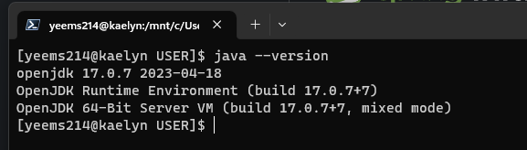

1. **Create SpringBoot application using Spring Initializr then Import the project in your IDE.**

* Open start.spring.io then configure the Spring Initializr to the appropriate requirements for your project.   
  A screenshot of a computer program

  Description automatically generated with medium confidence
* Add these dependencies to your project.  
  A screenshot of a computer program

  Description automatically generated with medium confidence
* Open your preferred IDE then import the project.
  + Jetbrains IntelliJ IDEA Ultimate
    - Open the hamburger menu then select File and Open.  
      A screenshot of a computer

      Description automatically generated
    - Navigate to your project’  
      A screenshot of a computer

      Description automatically generated
    - Your project should be visible now inside IDEA.  
      A screenshot of a computer

      Description automatically generated
  + Pivotal Spring Tool Suite
    - Inside Spring Tool Suite, click File then Import  
      A screenshot of a computer

      Description automatically generated with medium confidence
    - Once the Import window pops up, type in “Maven” below Select an input wizard then select “Existing Maven Projects” then Click next.  
      A screenshot of a program

      Description automatically generated with medium confidence
    - Inside Import Maven Projects, open Browse then locate your newly downloaded Spring Boot project that we downloaded from start.spring.io then click Open then once they have successfully imported, click Finish.  
      A screenshot of a computer

      Description automatically generated with medium confidence
    - Your project should be visible inside Package Explorer.  
      A screenshot of a computer

      Description automatically generated

1. **Create entities for your backend as per the scenario**
2. Car.java  
   A screen shot of a computer

   Description automatically generated with medium confidence
3. Users.java  
   A screen shot of a computer

   Description automatically generated with medium confidence  
   A screen shot of a computer

   Description automatically generated with medium confidence
4. **Create Repositories using JPA repositories.**
   1. CarRepository.java  
      A screen shot of a computer program

      Description automatically generated with low confidence
   2. UserRepository.java  
      A screenshot of a computer program

      Description automatically generated with medium confidence
5. **Create service layer to access the data in your API**
6. carRestApiService.java (Car Service)  
   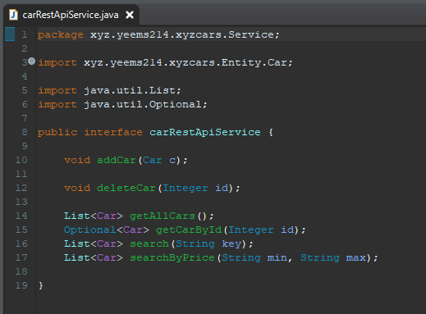
7. carRestApiServiceImpl.java (Implementation)  
   A screen shot of a computer program

   Description automatically generated with medium confidence
8. userRestApiService.java (User Service)  
   A screen shot of a computer program

   Description automatically generated with medium confidence
9. userRestApiServiceImpl.java (Implementation)  
   A screen shot of a computer program

   Description automatically generated with medium confidence
10. **Create controller for your application using REST API**
    1. CarApiController.java  
       A screen shot of a computer program

       Description automatically generated with low confidence
    2. UserApiController.java  
       A screen shot of a computer program

       Description automatically generated with medium confidence
11. **Test your API using POSTMAN tool.**
    1. User
       1. Registration  
          - API View  
          A screenshot of a computer

          Description automatically generated with medium confidence  
          - SQL ViewA screenshot of a computer

          Description automatically generated
       2. Login  
          - API View  
          A screenshot of a computer

          Description automatically generated- SQL View  
          A screen shot of a computer

          Description automatically generated with low confidence
       3. View All Users  
          - API View  
          A screenshot of a computer

          Description automatically generated with medium confidence  
          - SQL View  
          A screenshot of a computer

          Description automatically generated with medium confidence
       4. Search User  
          - API View  
          A screenshot of a computer

          Description automatically generated with medium confidence  
          - SQL View  
          A screenshot of a computer

          Description automatically generated with medium confidence
       5. Delete User  
          - SQL View (Before) 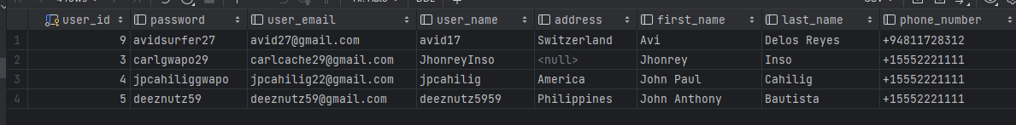- API View  
          A screenshot of a computer

          Description automatically generated- SQL View (After)  
          A screenshot of a computer

          Description automatically generated with medium confidence
    2. Car
       1. Add Car  
          - API View  
          A screenshot of a computer

          Description automatically generated- SQL View  
          A screenshot of a computer

          Description automatically generated with medium confidence
       2. Delete Car  
          - SQL View (Before)  
          A screenshot of a computer

          Description automatically generated with medium confidence- API View  
          A screenshot of a computer

          Description automatically generated- SQL View (After)  
          A screenshot of a computer

          Description automatically generated
       3. View All Cars  
          - API view  
          A screenshot of a computer

          Description automatically generated  
          - SQL View  
          A screenshot of a computer

          Description automatically generated with medium confidence
       4. View Car by Detail (id)  
          - API View  
          A screenshot of a computer

          Description automatically generated  
          - SQL View  
          A screenshot of a computer

          Description automatically generated with medium confidence
       5. Search Car by Keyword [make, model, registration, price]  
          - API View  
          A screenshot of a computer

          Description automatically generated  
          - SQL View [make]  
          A screenshot of a computer

          Description automatically generated with medium confidence
       6. Search Car by Price  
          - API View  
          A screenshot of a computer

          Description automatically generated- SQL View  
          A screenshot of a computer

          Description automatically generated with medium confidence